  

Develop your code push the code in local repository Pushing to github

clean package 

 

Deploy on tomcat Analyze the code

 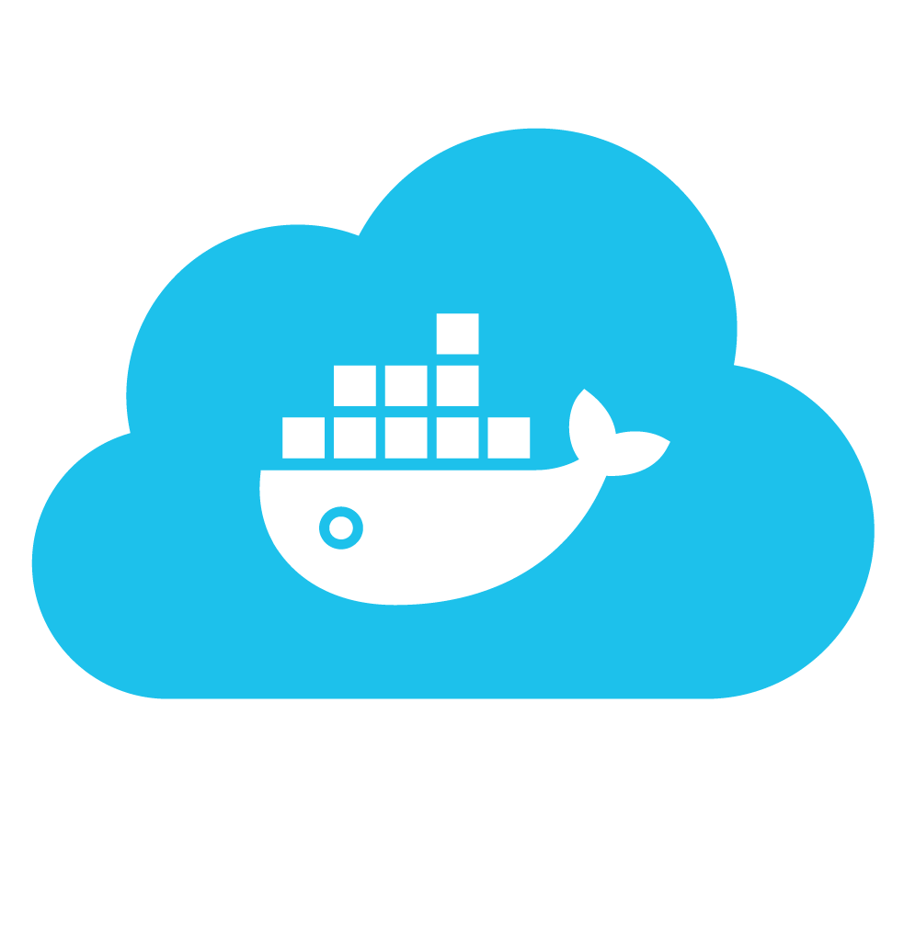 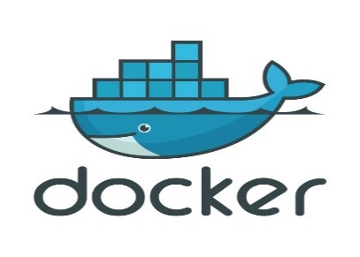

Push to jfrog artifactory Send to docker hub Create docker image

pipeline{

agent any

tools{

maven 'Maven'

}

environment {

registry = "diptib/dipti_all_project"

registryCredential = 'dockerhubdipti'

dockerImage=''

}

stages{

stage('Source'){

steps{

git 'https://github.com/Diptimb/SPring-mvc.git'}

}

stage('Clean-Package-create-war-file'){

steps{

sh 'mvn clean package -Dmaven.test.skip=true'

}

}

stage('Sonar Analysis'){

steps{

script {

Pipeline_Message=env.STAGE_NAME

echo "Sonar Analysis"

}

dir("/var/lib/jenkins/workspace/diptinewproject")

{

withSonarQubeEnv('sonarqube')

{

sh 'mvn sonar:sonar'

}

}

}

}

stage('Quality Gate')

{

steps

{

script

{

timeout(time: 1, unit: 'HOURS')

{

def qg = waitForQualityGate()

if (qg.status != 'OK')

{

error "Pipeline aborted due to quality gate failure: ${qg.status}"

mail bcc: '', body: 'quality gate pass failed', cc: '', from: '', replyTo: '',

subject: 'Gate passing Failed', to: 'deepubebarta@gmail.com'

currentBuild.status='FAILURE'

}

}

}

}}

stage ('upload') {

steps{

script {

def server = Artifactory.server "1"

def buildInfo = Artifactory.newBuildInfo()

buildInfo.env.capture = true

buildInfo.env.collect()

def uploadSpec = """{

"files": [ {

"pattern": "**/target/*.war",

"target": "libs-snapshot-local"}]

}"""

server.upload spec: uploadSpec, buildInfo: buildInfo

server.publishBuildInfo buildInfo

}}}

stage('Build image') {

steps {

echo 'Starting to build docker image'

script {

dockerImage= docker.build registry + ":$BUILD_NUMBER"

}

}

}

stage('Deploy Image') {

steps{

script {

sh 'docker login -u "diptib" -p "123456789" docker.io && docker push diptib/dipti_all_project'

docker.withRegistry( '', registryCredential ) {

dockerImage.push()

}

}

}

}

stage('Remove Unused docker image') {

steps{

sh "docker rmi $registry:$BUILD_NUMBER"

}

}

stage('Deploy'){

steps{

sh "cp /var/lib/jenkins/workspace/diptnewiproject/target/*.war /var/lib/tomcat8/webapps"}

}

}

post {

always {

mail to: 'deepubebarta@gmail.com',

subject: "Status of pipeline: ${currentBuild.fullDisplayName}",

body: "${env.BUILD_URL} has result ${currentBuild.result}"

}

}

}